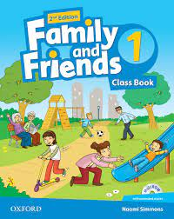 FAMILY AND FRIENDS 1:
Questions of Family and Friends books (1 to 6) for level placement
By Yousef Behravan

- Fill the empty letter: Bi…d a)r b)l c)s d)n
2- What is this? 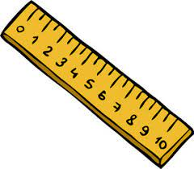 a) a pencil b) a pen c) a ruler d) an eraser 3- Who is this? a) a cook b) a boss c) a teacher d) a firefighter 4- Find the word in pictures: pineapple a) b) c) 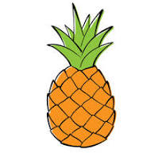 d) 5- What is the next? 11 12 13 ….. a) 16 b) 14 c) 15 d) 17 6- Look and write : a) a pen b)it a pen c) it is pen d) it’s a pen 7- Is he a doctor? a) yes, he is. b) no, he isn’t. c) no, he is d) yes, he isn’t 8- Where’s Grandma? 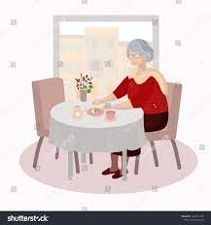 a) she is in bathroom b) he is in dinning room c) she is in kitchen d) she is in dinning room 9- … pants are green. 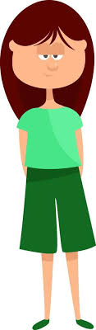 a) his b) Her c) their d) its 10- Do you like fish? 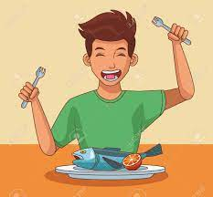 a) No, I like b) No, I don’t c) Yes, I do d) Yes, I don’t
Answer key of book 1: 1a, 2c, 3d, 4c, 5b, 6d, 7a, 8d, 9b

, 10c

Family and Friends 2 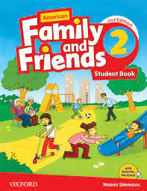 1- Continue the days of the week : Monday – Tuesday - Wednesday - … 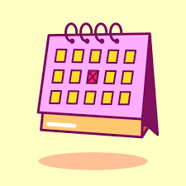 a) Saturday b) Sunday c) Thursday d) Friday 2- What’s that? a) it’s a computer b) it’s a laptop c) it’s a board d) it’s a keyboard
3- Fill the numbers. 20 – 30 – 40 – 50 - … - 70 - … - 90 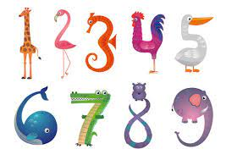 a) 60-80 b) 60-100 c) 80-60 d)60-70 4- What’s the weather like? a) it’s sunny b) it’s windy c) it’s hot d) it’s snowy 5- It’s eight fifteen a) 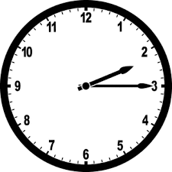 b) 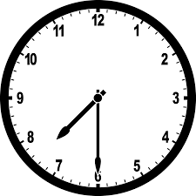 c) 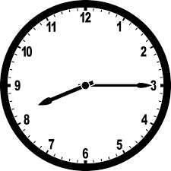 d) 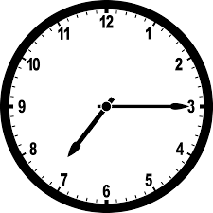 6- Write : 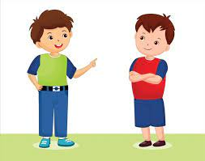 a) This is a boy b) Those are boy c) These are boy d) That is a boy 7- These are ….. bags. a) her b) his c) our d) its 8- He ……. candy. a) like b) likes c) does likes d) hates 9- Does she work in a hospital? 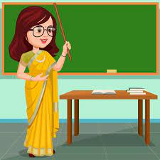 a) No, she doesn’t b) Yes, she does c) No, she does d) Yes, she doesn’t 10- The horse is …. than the cow. 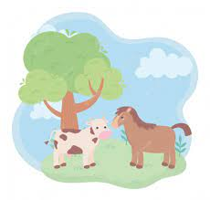 a) smaller b) shorter c) taller d) louder
Answer key of book 2: 1c, 2a, 3a, 4d, 5c, 6d, 7c, 8b, 9a, 10c

Family and friends 3 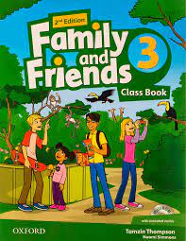 1- My uncle’s son is my… 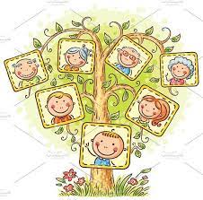 a) brother b) aunt c) cousin d) grandson 2- What’s this season? a) summer b) fall c) winter d) spring 3- Cross the odd word out: monkey- zebra- penguin- wood 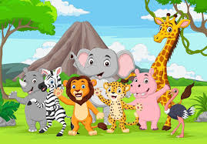a) wood b) zebra c) penguin d) monkey
4- Which one is older? a) child b) adult c) baby d) children
5- Which one is wrong? a) love 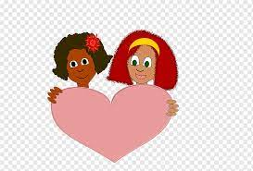 b) laugh 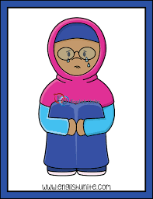 c) hate d) star
6- Look at that lovely house! I want to … of it. a) make photo b) take picture c) take a photo d) do a photo 7- Is the crocodile sleeping? 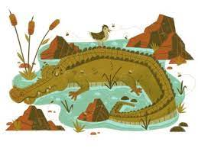 a) Yes, it is b) No, it isn’t c) Yes, it isn’t d) No, it is
8- _… you like playing computer game? _ Yes, I … a) Does, do not b) Do, don’t c) Does, do d)Do,do 9- 9- The boy likes … his books in the garden. 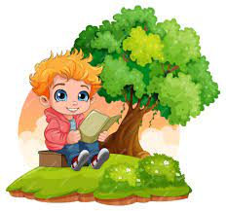 a) read b) to reading c) reading d) reads
10- Fifty years ago in Australia, there ... lots of kangaroos. a) was b) were c) is d) wasn’t
Answer key of book 3: 1,c_ 2,b_ 3,a_ 4,b_ 5,b_ 6,c_ 7,a_ 8,d_ 9,c_ 10,b

Family and friends 4 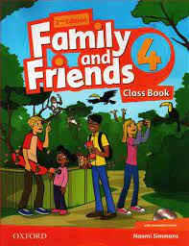 1- How many syllables? “Thursday” a) 3 b) 1 c) 4 d)2
2- The people who listen and watch a concert: a) audience b) violin c) singers d) cheer
3- Something that a lot of people like it is… . a) shadow b) popular c) love d) favourite
4- Passengers show their … to the gate to enter the airplane. 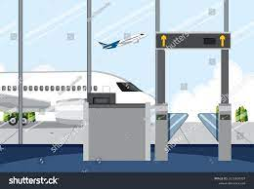 a) suitcase b) luggage c) passport d) money
5- Which one is different? a) computer b) board c) microphone d) mouse
6- What are you doing now? a) watching a video b) listening to song c) writing a story d) answering the questions
7- They always … to school by bus. a) went b) go c) going d) goes
8- How much money do you have? a) I have much money. b) I have 2 cents c) I have lots of dollars d) I don’t have any money.
9- She turned on the radio … to the news. 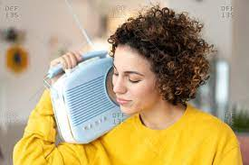 a) to sing b) to catch c) to listen d) to repeat
10- What should he do? a) He shoulds get some sleep b) He shouldn’t sleep c) He should stay awake d) He should sleep
Answer key of book 4: 1,d _ 2,a _ 3,b _ 4,c _ 5,b _ 6,d _ 7,b _ 8,d _ 9,c _ 10,d

Family and friends 5 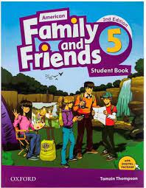
1- Mom keeps her …. in a box in the garage. a) gadgets b) tools c) school things d) makeup stuff
2- Harry was a prince in the play and he had a beautiful … . a) script b) stage c) costume d) curtain
3- Choose correct answers: He can use a broom/ tissue to sweep the floor. The barber/ servant served us the food. a) broom_servant b) tissue_barber c) broom_barber d) tissue_ servant
4- Think of a zoo, where can you see birds? 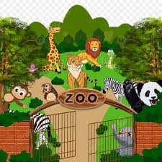 a) aquarium b) gift shop c) insect house d) aviary
5- Aylin cut her finger, so she should … it, she also has …. her hand with the stove too, poor her! a) plaster_burn b) bandage_burnt c) clean_burn d) bruise_burnt
6- They have lived in that house … 5 years. a) since b) for c) at d) as
7- Use the correct tense in this sentence: I was …. (play) video game when my mother … (call) me. a) played_called b) playing_was calling c) playing_called d) played_calling
8- Choose the correct one: Michael told/said me he was making an art project. Salesperson said/told all of their products were on the sale. a) told_told b) said_told c) said_said d) told_said
9- … I earn enough money, I … buy that dress. a) If_will b) As_will c) Will_if d) When_do
10- We can’t take pictures in here, …… we? a) shall b) can c) should d) can’t
Answer key of book 5: 1,b – 2,c – 3,a – 4,d – 5,b – 6,b – 7,c – 8,d – 9,a – 10,b

Family and Friends 6 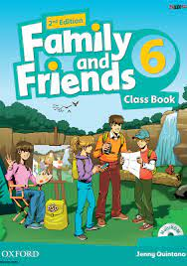
1- … a very big picture painted on the wall. a) portrait b) mural c) sculpture d) landscape
2- What are the negatives of these words: correct/obey a) incorrect_onobey b) uncorrect_inobey c) incorrect_disobey d) discorrect_disobey
3- He wants to … some pictures onto his page so that his friends can see them. a) upload b) attach c) get d) download
4- What are the correct suffixes for these verbs: use/comfort a) usement_comfortment b)usable_comfortness c) usable_comfortable d) useness_comfortable
5- The Sun and all of the planets are called: … a) Venus b) constellation c) solar system d) astronaut
6- Read and choose: She drinks/is drinking milk every night. We bought/ were buying our TV last year. a) drinks_were buying b) is drinking_bought c) is drinking_were buying d) drinks_bought
7- I … Greek food. ( eat ) a) ate b) have eaten c) have ate d) had ate
8- Read and choose: The new smart phone is being sold/is selling now. The foods are cooking/are being cooked, and they are on the dinning table. a) is being sold_ are being cooked b) is selling_are being cooked c) is selling_are cooking d) is being sold_are cooking
9- … you … (buy) something before you leave the city? a) Have_bought b) Had_bought c) Did_buy d) Do_buy
10- We wish the exams … (be) easier. She wish she … (can) tell her dad, that she loves him. I wish I … (have) to come this long. a) were_can_had b) was_could_have c) were_could_have d) were_could_had
Answer key of book 6: 1,b _ 2,c _ 3,a _ 4,c _ 5,c _ 6,d _ 7,b _ 8,a _ 9,b _ 10,d

Finished!

